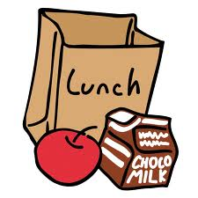

At the Canteen – March 2021

March 1 Wedges
March 2 Hotdogs
March 3 Perogies
March 4 Chili
March 5 Caesar Salad w/ Garlic Bread

March 8 Chicken Nuggets
March 9 Burrito
March 10 Penne Greek Salad w/ Garlic Bread
March 11 Chinese Fried Rice
March 12 Early Dismissal – No canteen

March 15-26 SPRING BREAK

March 29 Wedges
March 30 Pancake Brunch
March 31 Chicken Nuggets

